Data Structure Design

I used a 2D array for my players data:

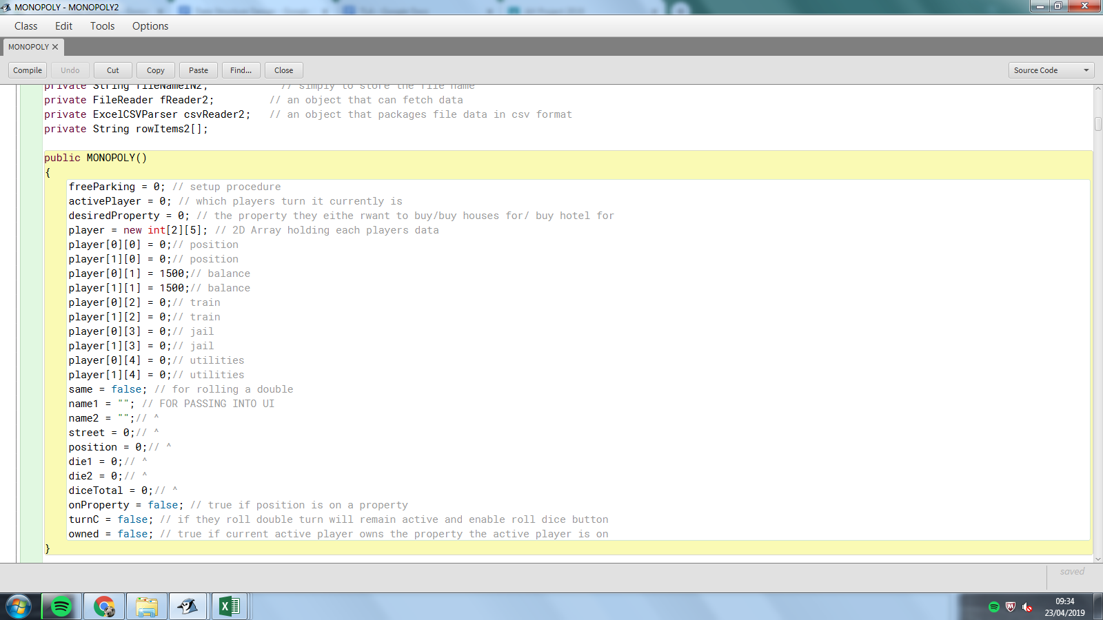

I decided to use an array which can have 2 items (this is because my game is a two player game so I need data for two players) in it which can have 5 attributes each these attributes were used for:

[0][0] is the players position on the board

[0][1] is the players balance

[0][2] is the amount of train stations the place owns (this is used to calculate the rent that should be charged when a train station is landed on)

[0][3] is the jail identifier, 0 is for them being outside of jail and 1 is used for being in jail

[0][4] this is the amount of the utilities the players owns this is used to calculate the amount a player would be charged if they land on an owned utility.

For community chest and chance I read in the card from a csv file called Cards.csv

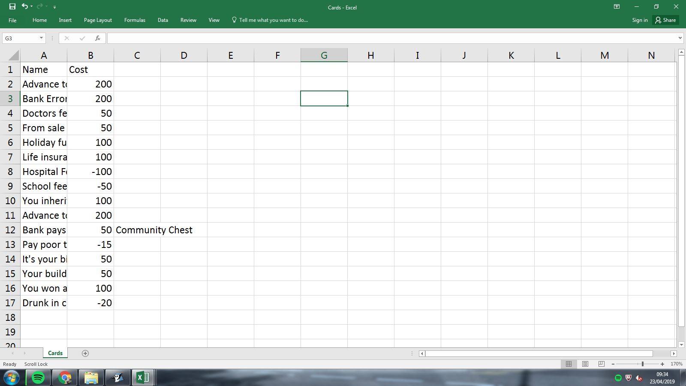

For the rent of properties I read in the data from a csv file called PropertyRent.csv

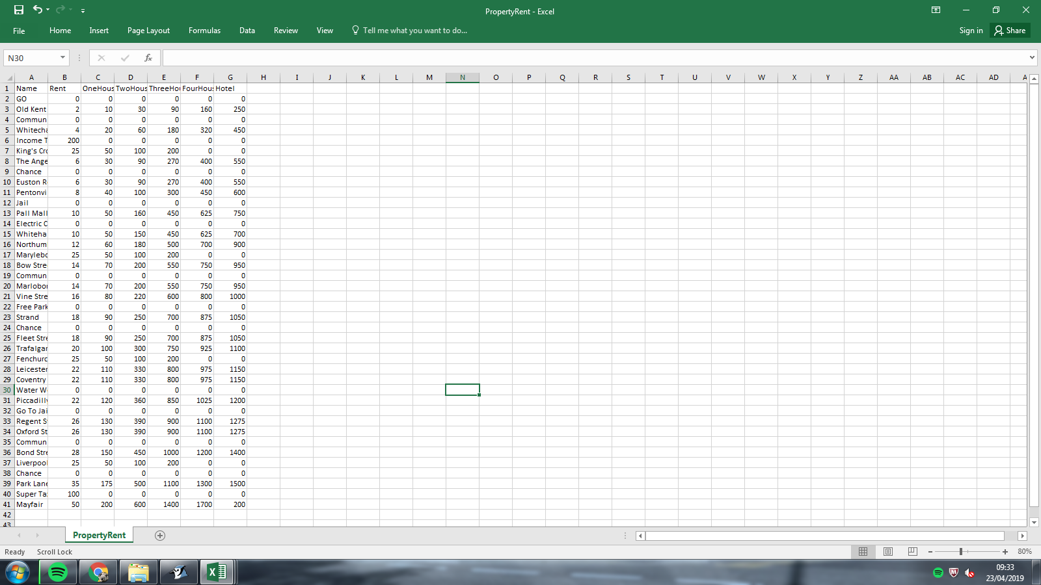

For the cost of properties and other details about the property I read them in from a csv file called PropertyCost.csv

